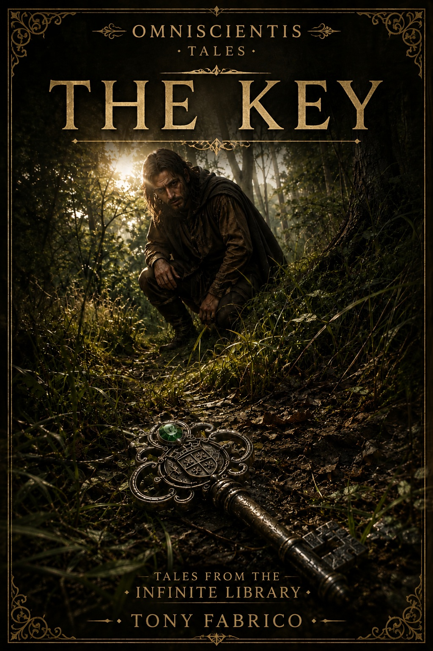

OMNISCIENTIS · Tales
The Key
© Tony Fabrico
First Edition · 2026
All rights reserved.
✦
This story is part of the Omniscientis narrative universe.
✦
No part of this publication may be reproduced,
distributed, or transmitted in any form or by any means,
without prior written permission from the author,
except as permitted by applicable law.

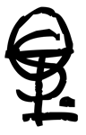

Prologue

Decisions.

Life forces us to make them. Every single day.

We choose a path. We trust a stranger.
We accept a job. We cross an ocean.
We build a family. We chase a dream.

Only afterward do we discover whether the choice was the right one.

There is something peculiar about that.
Before we act, we never know the whole truth.
We never see the entire map. There is always something missing.

A conversation that never took place. A hidden danger. An opportunity that does not yet exist.

A consequence that will remain invisible until the moment it is too late to turn back.

We live surrounded by incomplete information.
And where knowledge ends…
imagination begins.

So we fill the empty spaces with hope.
With fear.
With memories.
With desire.

Little by little, we lose the ability to tell which part of what we believe truly belongs to the world…
and which part exists only within ourselves.

Perhaps that is why our greatest mistakes never feel like mistakes while we are making them.
Quite the opposite.
They usually seem perfectly reasonable.

Each step is justified by the one before it.
And when we finally realize we have been walking the wrong road, we discover another problem.
Turning back has a price as well.

Perhaps the mystery is not discovering what tomorrow will bring. Perhaps the real mystery is something else entirely.
A riddle that might be answered with a single question:
How do you make the right decision when reality is always incomplete?

The story that follows took place long ago, in a small village called Oldwood.
There once stood a farm there.

And this tale begins at that very place.

Act I — The Legend
“The mind fears the unknown more than it fears error.
Therefore, it clothes ignorance with certainty.
And that which it expects to find
becomes
the world it believes it has seen.
—Fabhrius

Chapter 1: The Iron Key
Part 1 – The Valley
Somewhere in the valley east of the mountains, where the Bager River flowed down from the highlands through the forests of Oldwood, lived a young farmer named Nohk.
His home was a modest wooden cottage built beside the river, on a narrow stretch of fertile land where he grew grain and kept a few animals—chickens, goats, and pigs.
He was not wealthy. But neither was he poor.
He had enough.
And in those days, that was a kind of wealth.
Each morning began with the golden light of dawn shimmering across the water. The afternoons passed in the fields, accompanied by the steady murmur of the river as it brushed against the roots of ancient trees. At night, when the wind drifted down from the mountains, the valley settled into such profound silence that the distant calls of owls could be heard from deep within the forest.
Nohk loved that place.
He knew every bend of the river, every tree, every path. He knew where the wildflowers bloomed in spring and where the first mushrooms appeared after the rain. That corner of the world seemed to exist beyond the reach of time. Everything there had found its perfect balance. The rains came when they were needed. The sun warmed the earth without scorching it. The crops flourished. The animals thrived. And the years slipped quietly by with a serenity that made it difficult to imagine anything could ever change.
Some afternoons he walked to the village. It was only half an hour away along the woodland path. There he bought tools, sold part of his harvest, or simply met his friends at the tavern. Those gatherings were among the few pleasures the region had to offer. The young men talked about trade, discussed the harvests, exchanged news, and dreamed of ventures that almost never came to pass.
And although they sometimes complained about the monotony of country life, deep down none of them truly wished it were different.
They were happy. Perhaps without even knowing it.
That afternoon seemed no different from any other. The sun was sinking slowly behind the mountains. A gentle breeze stirred the leaves. And Nohk was following the familiar path toward the village.
Then he saw something unusual.

A flash.
Something gleamed among the grass.
He stepped off the path and walked toward it.

✦ ✦ ✦

Part 2 – The Key
The glint came from the base of an ancient oak. Half-hidden beneath the undergrowth lay a piece of metal. Nohk pushed aside a few branches and picked it up.
It was an iron key.
Yet it looked unlike any key he had ever seen. It was larger than those used for ordinary locks, and the iron had been worked with remarkable precision. The bow was fashioned into an elegant pattern of flowing curves and interwoven geometric shapes. At its center rested a green gemstone about the size of a walnut.
The gem caught the afternoon sunlight and returned it in flashes of emerald. That was what had drawn his eye from the path.
Nohk turned the key over in his hands. It was heavier than he had expected. Along one side he noticed a symbol engraved into the iron. It resembled a coat of arms—or perhaps a royal seal. The key was far too valuable to belong to a common farmer. Perhaps some nobleman had lost it while traveling. Perhaps it had fallen from a passing carriage.
The gemstone alone might be worth a small fortune. He could sell it in the village.
With the right buyer, he might earn enough to purchase a new cart… or repair the roof before winter.
He slipped the key into a leather pouch and continued on his way.

✦ ✦ ✦

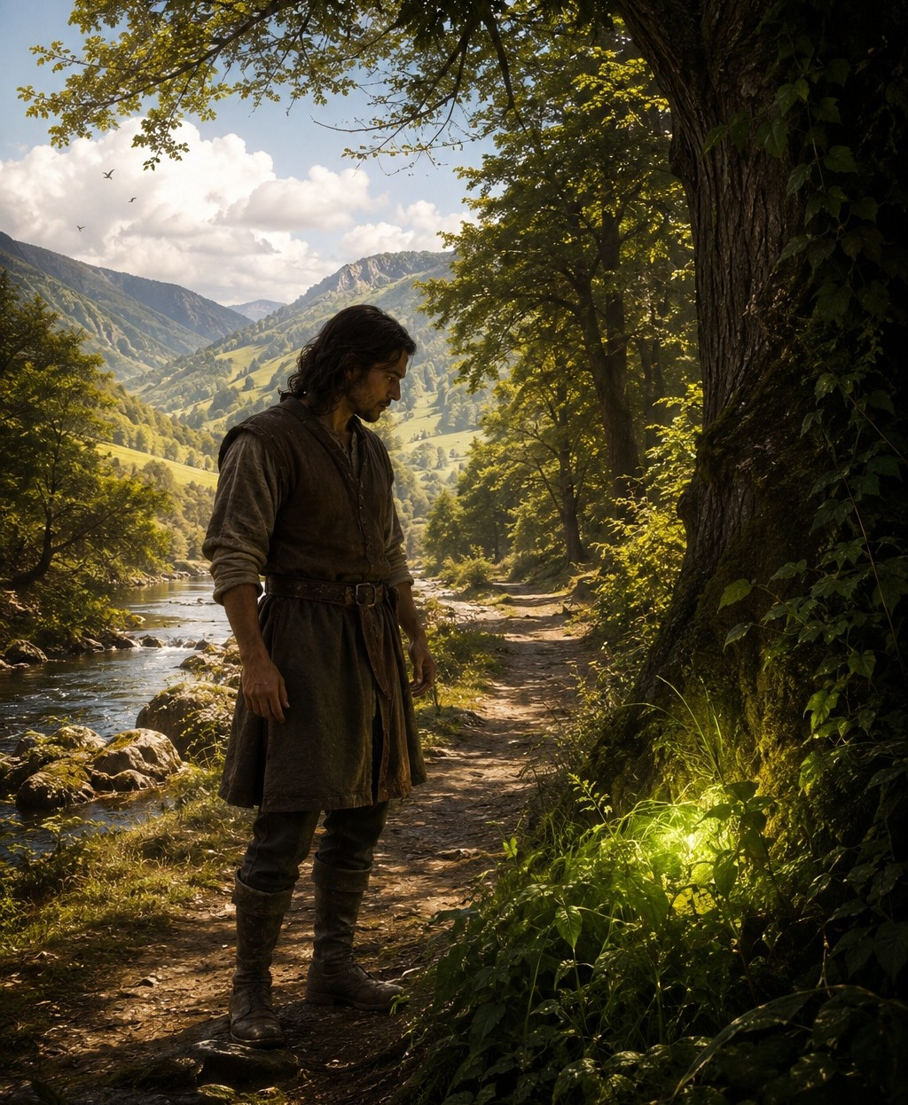
✧ A green gleam ✧

Part 3 – The Legend
As always when he came to the village, his first stop was the tavern. It was a large building of dark wood standing beside the main square. At that hour, it was already quite crowded. Farmers. Merchants. Craftsmen. Most of them were gathered around long communal tables, talking and laughing.
Nohk quickly found his friends. Five young men from the village were discussing trade, goods, and the prices of the harvests. Many of the region’s agreements began precisely there. Between mugs of ale and endless debates, business was made. Nohk took a seat.
—What do you make of this? —he asked.
And he placed the key on the table. The conversation stopped immediately. Everyone looked at the object. The green stone shimmered beneath the light of the lamps.
One of them lifted it and examined it in his hands. Another studied the symbol carved into the metal. A third tested its weight. For several minutes, they exchanged their opinions.
—It is not an ordinary key.
The words confirmed what Nohk had suspected. Perhaps he truly had found something valuable. The comments grew more enthusiastic with every passing moment. They discussed possible buyers. They estimated its worth. They imagined different ways of selling it.
Until one voice interrupted them.
—Wait. I have seen this key before.
The one who spoke was Ghim, the youngest of the group. He held the key in his hands and studied it with a strange expression.
—In an old book. At Jorhm’s house.
The words immediately caught everyone’s attention. Jorhm was an old man known for keeping a collection of manuscripts passed down through generations. Strange books. Ancient legends. Forgotten tales. No one paid them much attention.
—I am certain, —the young man continued—. It is the very same key.
Nohk no longer saw it as merely a valuable object. Perhaps that piece of iron carried a story of its own.
—If I were you, —Ghim finally added—, I would learn more before selling it. It may be worth far more than you think.
✦ ✦ ✦

Chapter 2: An Old Story
Part 1 – The Book
Jorhm’s house stood at the northern edge of the village, beside a small vineyard that sloped gently down toward the river. The six friends followed the path in almost complete silence. The excitement had replaced the jokes and laughter of the tavern. They all felt the same curiosity.
If the old man recognized the key, perhaps they could discover its true value. Or perhaps they could learn who had lost it.
When they arrived, they found Jorhm sitting beneath a vine covered with green leaves. The old man rested in a wooden chair, watching the sunset. The last rays of sunlight illuminated the vineyards and painted the stone walls of the house with gold. He seemed completely unaware of the commotion approaching along the path.
—Jorhm! —Kempht called as they drew near.
The old man looked up.
—What is it? Is the village on fire?
The young men laughed.
—Not exactly.
Kempht took out the key and held it up.
—Look at this.
Jorhm reached out his hand without much interest. But the moment his fingers touched the metal, his expression changed. The smile vanished. He brought the key closer to his eyes. Turned it slowly. Examined the green stone. Then the shield engraved into the metal. And finally, he looked once more at the gemstone.
For several seconds, no one spoke. The old man seemed unable to take his eyes away from the object.
—It cannot be… —he whispered.
He rose with a speed surprising for someone his age. Still holding the key, he walked toward the house.
—Come.
The six friends followed him. They crossed a narrow corridor and entered the main room.
The chamber was surrounded by shelves that stretched from floor to ceiling. Dozens. Perhaps hundreds of books. Some were carefully bound. Others looked so ancient that they seemed ready to crumble at the slightest touch. There were rolled maps, parchments, boxes filled with documents, and small objects gathered from distant lands. That collection was Jorhm’s pride. Within those pages survived forgotten stories and fragments of the past. The last remnants of life from the ancient peoples of Lluviara. And to him, those books represented his true wealth.
Jorhm walked directly toward one of the shelves at the back of the room. He did not hesitate for a moment. He knew exactly where to look. He removed a thick volume covered in dust. The binding was worn by the passage of years. The leather had darkened and cracked with age. With great care, he carried the book to a table. He opened it. The pages whispered softly as they moved. He turned several pages quickly. Then others more slowly. Until finally, he stopped.
His eyes widened. He placed the key upon the open page.
—Look.
The young men leaned over the table. On the page was a drawing. A key. Exactly the same. The same shape. The same green stone. The same royal crest engraved into the metal. Even the smallest decorative marks matched perfectly. It was not similar. It was the very same key.
No one spoke. The surprise had silenced the room. At last, Jorhm broke the silence.
—There is no doubt.
His voice sounded deeper than before.
—It is her.
—Her? —Nohk asked.
The old man slowly placed one hand upon the book.
—The key to the king’s treasure.
Jorhm looked once more at the key.
—And if this key is real… then perhaps the legend is real as well.
✦ ✦ ✦

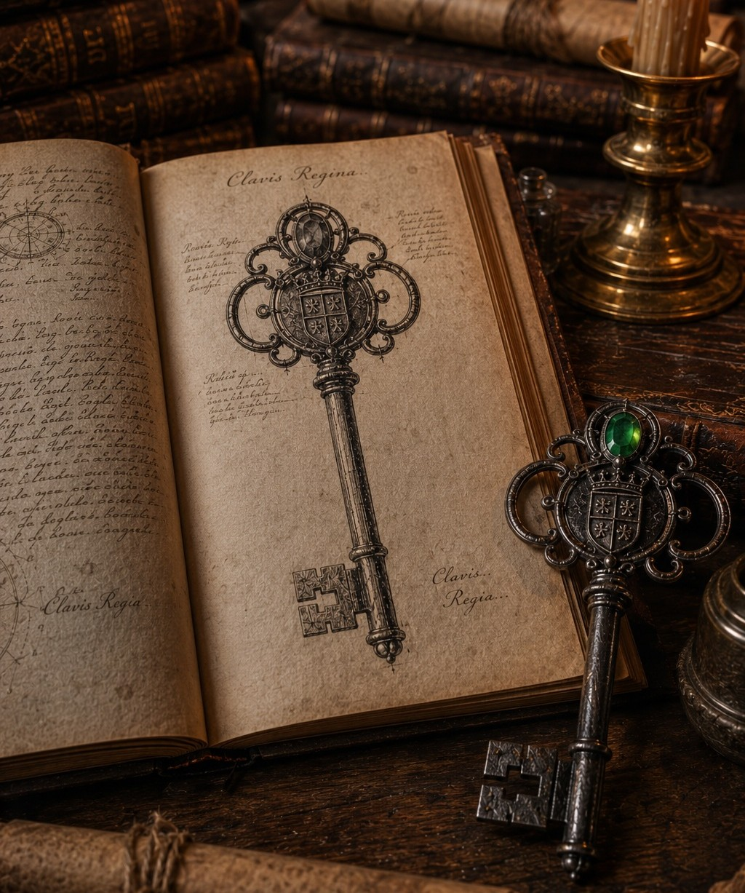
✧ The key and the book ✧

Part 2 – The Legend of the King’s Treasure
For several moments, no one spoke. The six young men remained leaning over the table, looking from the key to the drawing in the book and back again. The resemblance was so perfect that it was unsettling. Finally, it was Nohk who broke the silence.
—What legend is this?
Jorhm partially closed the volume and rested both hands upon its cover. He seemed to be gathering his thoughts.
Then he settled into a chair beside the table.
—It is a very old story, —he began—. So old that most people have long since forgotten it. According to this book, it happened nearly three hundred years ago, during the reign of Jumphrestebar.
The name meant nothing to the young men. Jorhm continued.
—In those days, a terrible war divided Lluviara. The eastern regions remained loyal to the king. The western lands sought to overthrow him. For years, both sides fought without rest. Entire cities were destroyed. Roads became dangerous. Trade vanished. No one knew who would emerge victorious.
The old man paused. The flames of a lamp flickered softly in the room.
—Over time, the situation grew worse. Eventually, the king was forced to abandon the capital and flee. His enemies advanced from every direction. He feared that if he was defeated, everything he possessed would fall into the hands of his enemies.
Jorhm opened the book again and turned several pages. Drawings of fortresses, ancient symbols, and texts written in a difficult script appeared before them.
—That was when the king made an extraordinary decision. He ordered the construction of a hidden chamber. A secret vault somewhere within Lluviara. There he would store the treasure of the Crown. Gold. Precious stones. Jewels worthy of emperors. Relics, works of art, and objects of immeasurable value. A treasure so magnificent that even imagination could scarcely contain it. Perhaps the greatest treasure that ever existed.
The young men listened in silence.
—According to the legend, the chamber was built to withstand any attack. Its walls were impenetrable. Its entrance was protected by an iron door that could not be destroyed. No army could break through it. No tool could open it.
The old man pointed toward the drawing of the key.
—Only one thing could open it. The key.
The boys’ eyes immediately turned toward the object resting on the table. The green stone seemed to shine even brighter beneath the lamplight.
—When the king realized that his death was near, —Jorhm continued—, he decided to preserve the secret. He summoned one of his most loyal servants and described the location of the chamber in exact detail. The man drew a map. One single map.
Jorhm turned several more pages. And there it was. A collection of lines, markings, and symbols drawn by hand centuries before. It appeared to be little more than a meaningless sketch. And yet everyone immediately understood what they were looking at. It was a map. The map of the treasure.
The young men leaned closer. Those ancient lines awakened their imagination in a way that was impossible to resist. Mountains. Rivers. Paths. Unknown places. Some hidden location where, according to the legend, a king’s fortune still waited.
Jorhm watched their expressions and let out a brief laugh.
—Do not look at me like that.
They all raised their eyes.
—I do not believe a single word of this story.
The young men looked disappointed.
—You do not? —Kempht asked.
—Of course not.
Jorhm closed the book gently.
—It is a tale for children. A legend. Nothing more.
He leaned back in his chair.
—If that vault truly existed, someone would have found it centuries ago. Many people searched for the treasure. Some used copies of this very map. Others followed different clues. None of them ever found anything.
The old man tapped his fingers against the cover of the book.
—Neither the chamber nor the key was ever discovered.
He looked once more at the drawing. Then at the key. Then back at the drawing. His expression changed slightly. The certainty in his voice seemed to weaken.
—And yet…

The room fell silent.
Jorhm took the key into his hands. He turned it slowly. Examined the engraved crest. The green stone. The patterns in the metal. Then he compared it with the illustration once more. And again. As if hoping to discover some difference. But he found none. Finally, he released a long breath.
—I would swear this is impossible.

No one spoke. The old man continued staring at the key with a mixture of fascination and confusion. He seemed to doubt his own beliefs.
And that was far more unsettling than the legend itself.
✦ ✦ ✦

Chapter 3: The Beginning
Part 1 – The Purchase
Over the following days, the key became the subject of every conversation. At first, it was only a curiosity. A strange object found in the forest.
But the human mind rarely settles for a simple explanation when a more exciting one exists.
Every afternoon, the young men gathered at the tavern. And every afternoon, the conversation inevitably returned to the same subject. The key. The king. The treasure. The map. At first, they discussed possibilities. Then they began discussing certainties.
What if the legend was true? What if that key truly belonged to the king? That last idea was especially powerful. They had the key. The real one. The very same key shown in the book. The more they talked about it, the more reasonable it seemed. And the harder it became to think of anything else.
Nohk began imagining chests overflowing with gold coins. Kempht spoke of buying land. Others dreamed of opening businesses, building larger houses, or traveling to places they had never seen. The king’s fortune began to take shape in their minds. It was no longer a legend. It was an opportunity. An extraordinary one. A unique one.
Eventually, they decided to return to Jorhm’s house. They needed to see the book again. They wanted to study the map carefully. Perhaps the answer had been there all along. Perhaps those seemingly chaotic lines concealed precise instructions.
But when they arrived, the old man refused.
—No.
The answer came immediately. He did not even allow them to finish speaking.
—You have seen enough.
The young men insisted. They tried to reason with him. They explained their theories. They showed him the key once more. But Jorhm remained firm.
—Listen carefully, —he said seriously—. You are turning a story into an obsession.
Those words angered them. Because deep down, they all knew he was right.
The old man studied their faces. He saw the anxiety. The hope. The ambition. And something else. Something that was beginning to worry him.
—It is a legend, —he continued—. A tale invented centuries ago. No one ever found the treasure. No one ever found the vault. And no one ever found the key.
He raised his eyes toward Nohk.
—Do not allow an old story to make you forget reality.
But his warnings came too late. During the following days, imagination did the rest. Each conversation strengthened the one before it. Each doubt was answered by a new possibility. Each objection found an explanation.
Little by little, the existence of the treasure stopped being a possibility. It became a conviction.
The young men began to feel like people who already possessed a fortune, even though they had not yet held a single coin in their hands. The wealth seemed to be waiting for them. Hidden. Patiently.
Eventually, an idea emerged. Simple. Direct. Inevitable.
—What if we buy the book?
The proposal fell upon the table like a revelation. For several seconds, no one spoke. Then they began to nod. Of course. That was the solution. If Jorhm would not lend it to them, they could purchase it. Everything had a price. They only needed to offer an amount high enough. An amount impossible to refuse.
And so they began gathering money. They sold animals. Tools. Goods. Carts. Everything they could spare. When they finished, they had gathered more money than any of them had ever held in their hands before. A small fortune.
Perhaps the greatest investment they would ever make in their lives. And one morning, carrying a heavy bag filled with coins, the six friends once again walked the path leading to Jorhm’s house. They were certain that this time they would return with the book. And with it…
the first step toward the king’s treasure.

✦ ✦ ✦

Part 2 – The Adventure Begins
Jorhm saw them coming long before they reached the house.
He was sitting beneath the vines, in the same place where he often spent his afternoons watching the valley. From there, he could see the path that climbed up from the village. And that day, he recognized them immediately. The six of them walked together. Determined. With a clear purpose.
The old man sighed. He had hoped that their excitement would fade with the passing of time. That the initial enthusiasm would disappear. That reason would eventually prevail. But it had not happened. Quite the opposite. Something had changed in them. He sensed it even before hearing a single word. That mixture of hope and anxiety shining in their eyes troubled him. He had seen that expression before. In ruined merchants. In gamblers. In men convinced they were about to discover a fortune. And it rarely ended well.
The young men reached the table. Nohk was the first to speak.
—Jorhm, we want the book.
The old man looked up.
—I already told you what I think of that story.
—We have come to make you an offer.
For a moment, no one spoke. Then one of the young men placed a heavy leather bag on the table. The coins clinked against the wood.
Jorhm looked at the bag. Then at the young men. And finally back at the bag. His expression changed.
—What is this?
—Two hundred coins.
The old man opened his eyes in surprise.
—Two hundred?
Nohk nodded.
—Two hundred coins for the book.
Jorhm remained silent. The amount was absurd. With that money, he could live comfortably for years. It was far more than any book he owned was worth. Even that one. He slowly shook his head.
—Boys… the vault does not exist.
No one answered.
—It is a legend. A story invented long ago. Nothing more.
The six remained still. Nohk held the old man’s gaze.
—Two hundred coins for the book.
Then Jorhm understood. The discussion had ended before it had even begun. These young men were no longer seeking advice. They had already made their decision. The money was merely a formality.
He looked at the bag once more. Then at the book he had guarded for so many years. And finally, he looked back at the young men.
A vague sense of concern filled him. As if he were handing them something far more dangerous than an old volume.
—I see that you have made your decision, —he said at last.
No one answered. There was no need.

✦ ✦ ✦

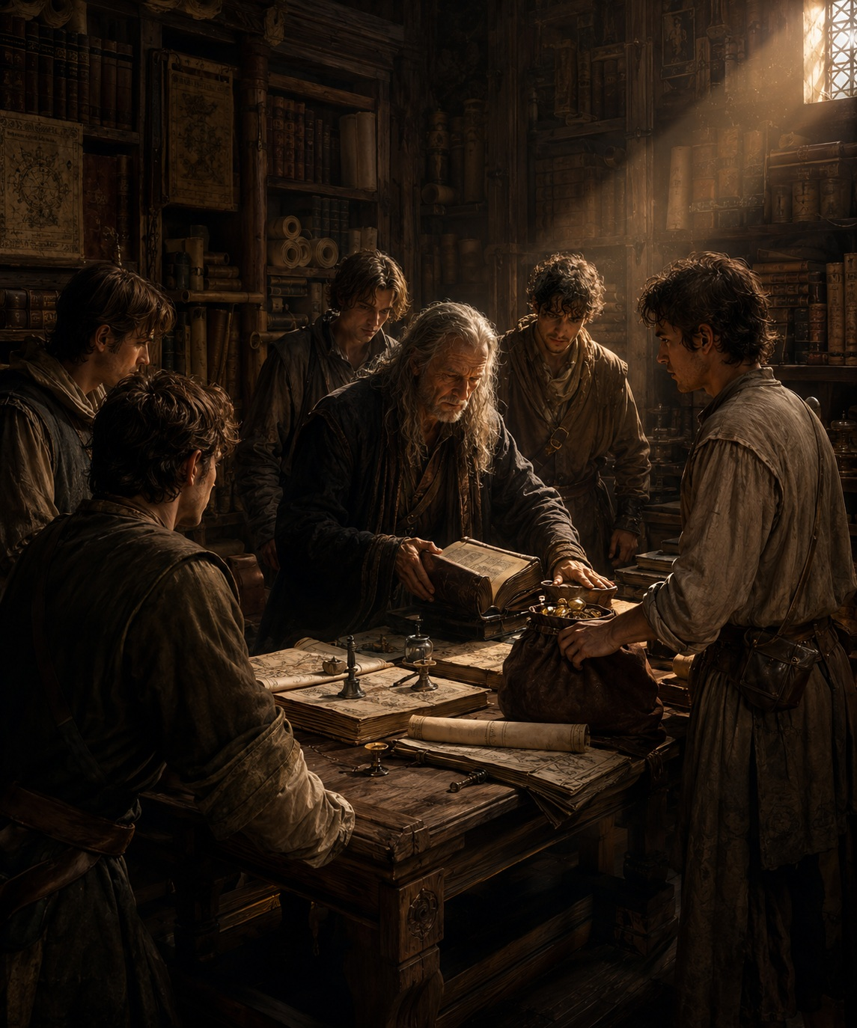
✧ The purchase ✧

Part 3 – The Pact
That same night, they gathered at Nohk’s house. The book occupied the center of the table. The lamps remained burning until deep into the night.
Again and again, they studied the pages. They compared symbols. They examined notes. And above all, they analyzed the map. To everyone’s surprise, it was far easier to understand than they had imagined. It was not a collection of meaningless scribbles. The geographical features matched places they knew. The references appeared to be real. And most importantly of all, the destination marked on the map was not on the other side of the world.
It was relatively close. To the west. In the mountains. Only a few days’ journey away. Perhaps three. The revelation filled the room with excitement.
The treasure was no longer a distant legend. Now it had a location. A specific place. A destination. Something they could reach. Something they could find.
The king’s fortune seemed to be waiting for them. Hidden for centuries. Only a few days away.
The conversations grew more animated. The laughter became louder. Each of them was already imagining the future that awaited them. Lands. Houses. Businesses. Livestock. Freedom. A wealth beyond anything an ordinary farmer could ever hope to possess. Finally, Nohk raised his cup. The others did the same.
—When we find the treasure, —he said—, we will divide it equally among us.
The five immediately nodded. It was fair. They had begun together. They would finish together.
—Partners, —Kempht declared.
—Partners, —the others repeated.
The cups struck together. The pact was sealed.
A king’s treasure divided among six men. There would be more than enough for everyone. That night, none of them hesitated. None of them felt afraid. None of them imagined what those words truly meant.

Meanwhile, the iron key lay silently upon the table…
as if watching them.

✦ ✦ ✦

Act II — Reality
The mind may wander along a thousand paths.
But only the feet discover the stones beneath them.
The deepest truths
remain hidden from imagination.
And they are revealed only
to those who choose to walk.
—Fabhrius

Chapter 1: The Wilderness
Part 1 – The Expedition
For several days, they studied the map with great care. They compared the ancient drawing with newer maps of the region and produced a larger, far more detailed copy. Upon it, they added notes, estimated distances, and landmarks.
Every afternoon, they spread the map across the table in Nohk’s house and spent hours tracing with their fingers the lines that had been drawn centuries before.
They identified mountains, rivers, forests, and familiar roads. They debated different routes, calculated each day’s journey, and marked the best places to make camp. They estimated how long each stretch would take and planned how they would overcome the obstacles they expected to encounter.
Before long, they were no longer discussing a possibility. They were planning an expedition.
According to their calculations, they would reach the mountains in two days. Beyond that point, they would have to leave the known roads behind and venture into a region that was all but unexplored. If the map was accurate, the vault could not be much farther.
Their excitement made the waiting almost unbearable. Each day they remained in Oldwood was another day the treasure lay hidden beneath the mountains. Every conversation ended the same way—with the vault, the key, or King Jumphrestebar. The lost fortune seemed closer with every passing day.
Preparing for the expedition proved far more expensive than they had expected.
They bought a wagon large enough to carry all six men and everything they would need for a week’s journey. Two strong horses. Barrels of water. Sacks of flour. Salted meat. Tools. Climbing ropes. Blankets. Tents. Oil lamps. And anything else that might prove useful on a journey whose destination they barely understood.
The savings they had accumulated through years of hard work began disappearing one purchase after another. But none of them hesitated. Each was convinced that the cost would be insignificant compared to the wealth awaiting them at the journey’s end.
The preparations took nearly a week. While some inspected the equipment, others reinforced the wagon, bought supplies, or settled the affairs they would leave behind in the village. When everything was finally ready, there was nothing left to do but wait for dawn.
Morning arrived bright and clear. The rains of the previous days had left the air cool and crystal clear. From the valley, they could see the mountains rising along the western horizon with remarkable clarity.
They loaded the wagon. Fastened the harnesses. The horses started forward as the wheels creaked over the dirt road. The six friends left Oldwood convinced they were traveling toward the greatest treasure ever hidden in Lluviara.

None of them imagined how different the journey they had drawn upon the map would be from the one they were about to travel.

✦ ✦ ✦

Part 2 – The Storm
On the second day of their journey, they reached the vast marshes surrounding the Straripante River. They had already covered nearly half the distance. The landscape changed completely.
The forests vanished. Solid ground became scarce. The river split again and again into countless channels that wound through the mud. Small islands of grass rose above stretches of dark water that seemed to have no end.
The road narrowed until it became little more than a strip of earth barely higher than the marsh itself.
Gradually, they found themselves surrounded by water and reeds in every direction. From anywhere within the marsh, the landscape looked exactly the same. Without knowing the trail, a traveler could wander for hours without getting any closer to his destination. The Great Marsh was a vast labyrinth from which few travelers escaped without difficulty.
The ground inspired little confidence.
Water and clay had formed a thick, clinging mud that seized their boots with every step. Progress demanded constant effort. The horses sank deeper with every stride, and the wagon groaned as its wheels struggled to keep from becoming trapped. Still, they pressed on.
Throughout the morning, the sky remained clear. The sun shone upon the still waters of the marsh, and the air was warm and heavy with moisture. But as afternoon wore on, the first clouds appeared in the west.
At first, only a few dark patches. Then a great black mass that slowly swallowed the horizon.
The wind shifted. The air grew heavy. Silent. Unsettling. Kempht looked up.
—I do not like this.
No one answered. This was no place to spend the night. They had to cross the marsh before darkness fell.
The first drops of rain came only minutes later.
Small. Scattered. Harmless. Then came more.
And more.
The wind began to howl. The horses grew restless. A distant roll of thunder echoed across the marsh. Then the storm arrived.
It came so suddenly that no one had time to react. The sky vanished behind an immense wall of black clouds. Lightning tore across the darkness. Thunder shook the air. Then the rain came crashing down upon them with unimaginable force.
It fell so heavily that it became difficult to keep their eyes open. Visibility vanished. Each man could barely make out the silhouettes of the others.
—Keep moving! —Nohk shouted.
But every step became harder than the last. The Straripante River had begun to overflow.
The water covered the road. Then their ankles. Their knees. Before long, it had risen to their waists. No one could tell where the road ended and the river began.
Perhaps they had wandered off the trail. Perhaps the river had swallowed the entire marsh. Perhaps both.
The mud disappeared beneath the rising water. The horses struggled desperately, fighting at every step to free their legs from the mud that gripped them. Then it happened.
The wagon’s front wheel suddenly sank to its axle.
The horses reared and pulled with all their strength. The harnesses stretched tight. The wood groaned. For a few seconds, it seemed they might free it. But the ground gave way beneath the enormous weight of the load.
The second wheel began to sink as well. The marsh slowly started to swallow the wagon.
As though it had been waiting patiently for that very moment. The six men pushed. They dug with their hands. They wedged branches beneath the wheels.
It was useless.
Every effort only drove the wagon deeper into the mud. Then they realized it was lost. They hastily unloaded everything they could save. Each man took upon his shoulders as much as he could carry. The rest was abandoned.
Nohk turned back one last time. He could barely make out the wagon through the rain. A flash of lightning illuminated the marsh. For a single instant, he watched the mud consume the wagon, along with their supplies, their tools, and much of everything they had spent weeks gathering. Then darkness returned.
The rain beat down with relentless force. The mud tried to pull the boots from their feet. They struggled onward for what felt like hours, fighting to escape the marsh.
At last, they reached a rocky rise that stood above the floodwaters.
There they remained in silence. Waiting. By the time night fell, the rain had stopped. Before them stretched a vast, dark lake. The landscape had been transformed. Where a road had existed only hours before, there was now nothing but water.
No one could point to where the wagon had disappeared. Or the horses. Or the path that had led them there.

The marsh had erased every trace of their passage.

✦ ✦ ✦

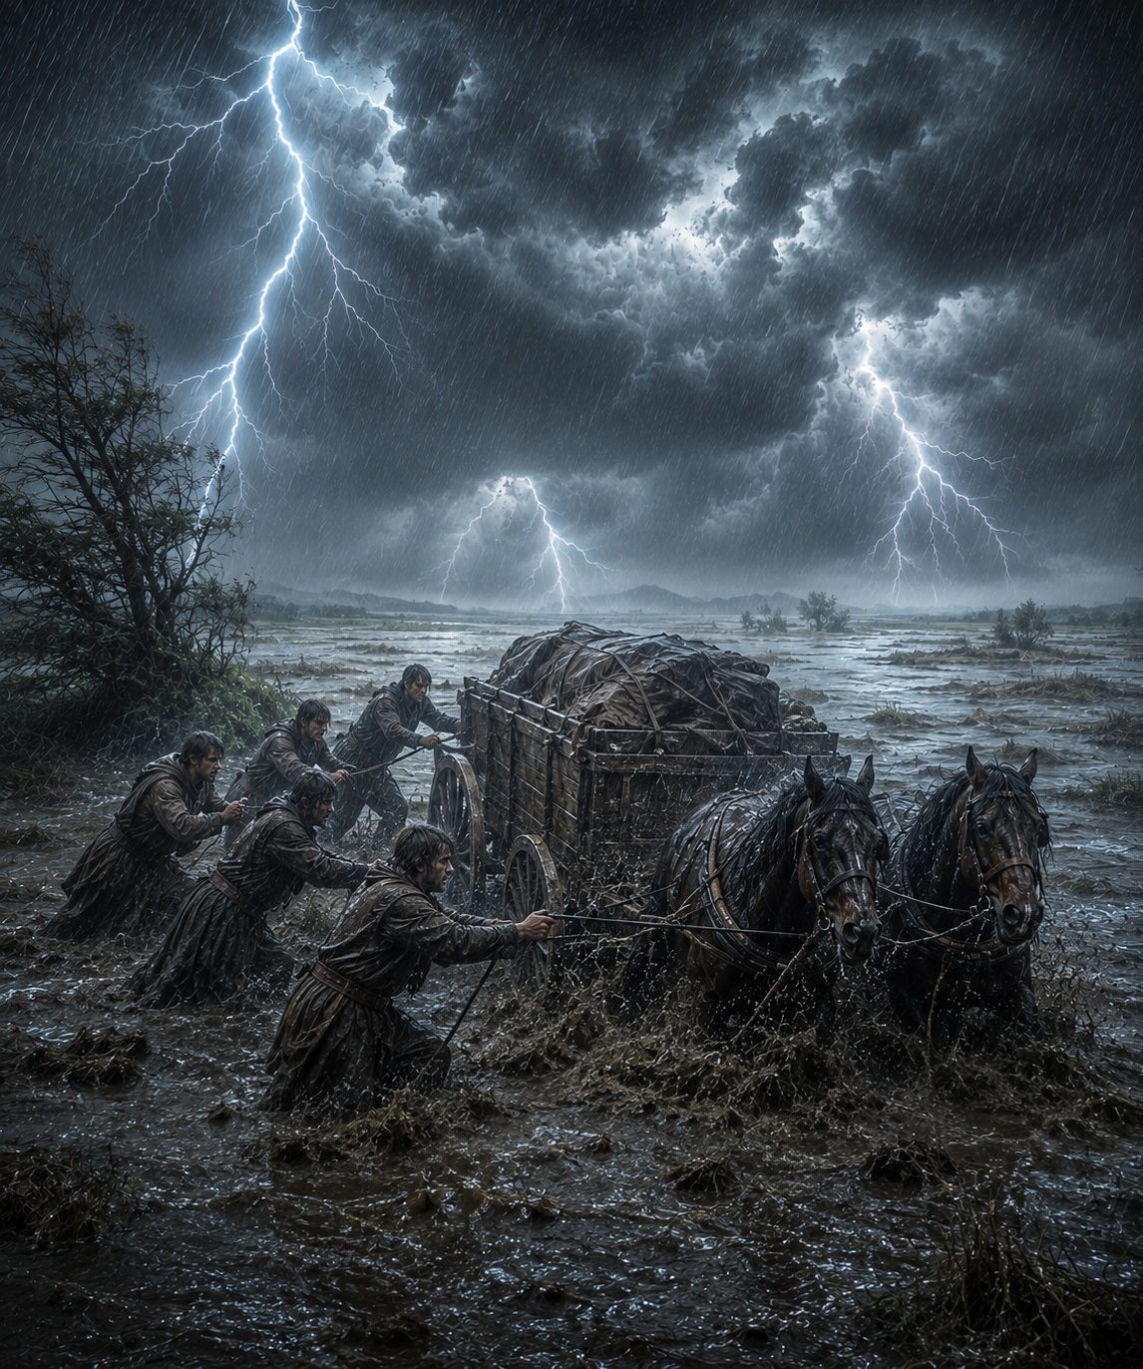
✧ The storm ✧

Part 3 – The Bridge
The days that followed proved far more difficult.
Without the wagon, each man had to carry on his back everything he had managed to save from the storm. Their supplies had been greatly reduced. Progress became slow and exhausting. By nightfall, they scarcely had the strength to raise their tents. The excitement with which they had left Oldwood was beginning to fade.
At last, they reached the mountains. According to their calculations, the place marked on the map could not be much farther away. Perhaps fifty miles. Perhaps less. After everything they had endured, the end of the journey seemed almost within reach. That was when they arrived at the edge of the cliff.
The road ended there.
Before them lay an immense gorge, plunging hundreds of feet down to the river below. Its walls fell almost straight down, smooth and dark. Far beneath them, the river crashed against the rocks with a ceaseless roar that rose to them as a distant echo.
Every one of them searched for the bridge.
It was gone. Only the remains of the old stone pillars still stood, clinging to either side of the chasm. The suspension bridge shown on the map had vanished long ago. Perhaps it had collapsed during a storm. Perhaps it had been destroyed in some forgotten war. It no longer mattered.
The route no longer existed.
No one spoke. They stood motionless, staring into the abyss, as though expecting some hidden solution to reveal itself among the cliffs. For several minutes, the only sound was the roar of the river. Johf was the first to break the silence.
—It is over.
No one argued. They had lost the wagon. The horses. Much of their food. And now… the road itself.
Returning to Oldwood would mean admitting that everything they had sacrificed had been for nothing.
Nohk continued staring into the chasm. Then he spoke.
—I am not going back.
His voice was strangely calm.
—We have come too far to turn back now.

No one answered at once. They all understood the danger. But they also understood the weight of everything they had already lost to reach that place. It was Kempht who pointed toward the face of the cliff.
—If we can climb down to the river… perhaps we can make our way up the other side.
They all looked where he was pointing. The cliff was almost vertical. The rock offered scarcely enough footing to support a man. One mistake would mean a fall of hundreds of feet. It was madness.
And yet… they began studying the cliff as though it were a reasonable possibility.
After a time, they made their decision. They would descend the cliff. Cross the river. And attempt to climb the opposite wall.
Not one of them would have accepted such a risk before setting out on the expedition.
Now… it seemed entirely possible.

The boundary of what they considered acceptable had shifted.

✦ ✦ ✦

Chapter 2: Decision
Part 1 – The Impossible Ascent
The descent down the western cliff proved far more difficult than they had expected. The height was dizzying. The rock offered little more than narrow cracks where the tip of a boot—or the fingers of a hand—could find purchase. Every yard demanded the same ritual: find a foothold, test it, and trust that it would bear their weight. It did not always do so.
Fragments of stone broke loose beneath their feet and vanished into the abyss. Several seconds passed before the echoes of their impact rose from the bottom of the gorge. No one spoke. Only the whistle of the wind, the rough scrape of ropes against the rock, and, far below, the endless roar of the river.
By the time they finally reached the foot of the cliff, the sun was already sinking. The river rushed between two towering walls of stone. It was not wide—barely twenty yards across—but its current was savage. The water crashed against the rocks with enough force to break bones.
An old fallen tree stretched nearly halfway across the river. Beyond that, there was no path. Someone would have to jump. Johf volunteered without hesitation.
He tied a rope around his waist, checked the knot twice, and waited. He studied the current. Drew a deep breath. Then threw himself into the water. The river struck him like a hammer. The current tore him instantly from his course and swept him several yards downstream. He fought toward the opposite bank, but the water hurled him against a boulder. For an instant, he disappeared beneath the white water. The rope snapped tight. From the shore, the others could do nothing but hold fast… and wait. Johf surfaced again, coughing violently. He clung to a rock. Lost his grip. The current seized him once more. He tried again. And again.
Just as his strength seemed spent, he reached a narrow ledge beside the opposite bank. With the last of his strength, he pulled himself onto it, scrambled across the slippery rocks, and secured the rope around the trunk of a tree. One by one, the others crossed, clinging to the rope while the river struggled to tear them away.
By the time they reached the foot of the eastern cliff, the sun had disappeared behind the mountains. Only then did they understand the true scale of the obstacle.
The wall of granite rose before them like an immense fortress of gray stone. A thousand feet of near-vertical rock climbed toward the orange glow of the evening sky. No one spoke. For several minutes, they stood motionless, searching the mountainside for a weakness that did not exist.
There were no paths. No ledges. No obvious route. Only an immense wall of stone reaching toward the heavens. Johf was the first to break the silence.
—It is impossible.
No one answered. That single word expressed what every one of them was thinking. The mountain had won. They needed only to turn around, follow the river, and return to Oldwood. They still had their lives. But no one moved. They had crossed forests. Traversed the Great Marsh. Lost the wagon. The horses. Most of their supplies. Descended a cliff that no sensible man would ever have attempted. And according to the map… the treasure lay beyond that wall.
So close.
Nohk stepped toward the rock. He placed one hand upon the cold granite and slowly searched the cliff with his eyes.
—There has to be a way.
No one argued. For the rest of the afternoon, they examined the mountain from every angle. They searched for cracks, ledges, narrow shelves—any irregularity that might offer the beginning of a climb. They found very little.
When night fell, they made a small camp beside the river. The fire cast only a faint light against the darkness descending over the valley. They ate in silence, sharing what little food remained. Then they looked once more at the mountain.
It was still there. Motionless. Indifferent. As though patiently waiting for them to make their decision.
No one slept. Each man lay awake, staring at the immense wall of stone beneath the moonlight. They knew attempting the climb would be reckless. They also knew that, when morning came… they would try.

For the closer they believed themselves to be to the treasure… the more unbearable the thought of returning empty-handed became.

✦ ✦ ✦

Part 2 – The Trap
At dawn, as soon as there was enough light to make out the cracks in the rock, they prepared the ropes, divided the equipment, and began the ascent.
The first stretch was almost easy. The cliff offered solid handholds and firm footing. Deep cracks, narrow ledges, and enough projections to climb with confidence. The summit seemed close. The treasure… within reach.
They kept climbing. Ten yards more. Twenty. Fifty. The river dropped farther below them. The trees shrank into a green carpet. The wind grew stronger. Then came the first signs of trouble.
The cracks became fewer. The ledges narrowed. Every new move demanded a little more reach, a little more balance, a blind search for a handhold that often was not there. Their progress slowed to a crawl.
One climber would remain perfectly still for long minutes, studying the rock. Only after finding a possible route would he climb a few more inches, allowing the next man to take his place. No one spoke anymore. Only heavy breathing. Boots scraping against stone. The faint creak of ropes pulled tight. They had climbed more than three hundred feet before they finally understood the true nature of their mistake.
It was not that the climb had become difficult. It was that the route had ceased to exist.
The lead climber stopped before a stretch of smooth stone. He searched for a crack. Ran his fingers across the rock. Tested a small protrusion. It crumbled beneath his touch. There was nothing to hold on to. He tried to climb back down. Then he made another discovery. He could not.
Descending meant searching blindly for footholds hidden beneath his boots. One wrong movement… and he would lose his balance.
One by one, the climbers stopped moving. The entire line hung motionless.
Suspended more than three hundred feet above the ground. With nowhere to rest. Without the strength to remain there for long. With no way forward. And no safe way back.
Then, clinging to the mountainside, frozen by vertigo… no one thought about the treasure.
There was only the cliff. And the abyss.

At last, they understood a terrible truth.
They were no longer climbing the mountain.

The mountain had trapped them.

✦ ✦ ✦

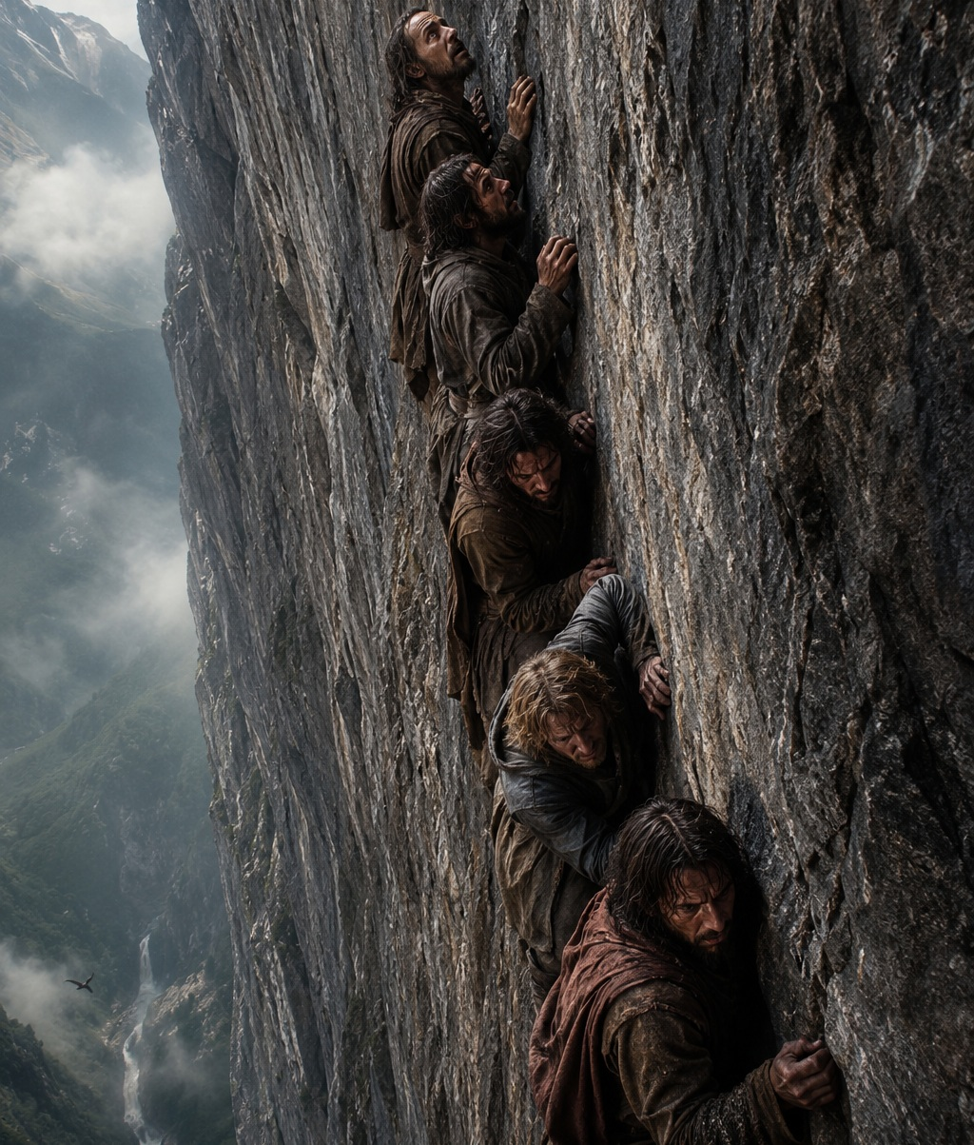
✧ Trapped ✧

Part 3 – The Point of No Return
The wind grew stronger. And everything seemed to become more difficult.
From the foot of the mountain, with solid ground beneath their feet, the climb had looked far easier. Now it was something else entirely.
The summit seemed to drift farther away with every passing minute.
Time slipped by, yet no one managed to climb another step. Simply clinging to the rock had become an unbearable effort.
Ghim, the youngest of the group, managed to move one hand. Then he found another foothold. Then another handhold. He climbed one step higher.
Perhaps his eyes were beginning to adjust, allowing him to see possibilities the others had missed. Or perhaps he understood that, sooner or later, to stop climbing meant to fall.
He began to notice tiny cracks the others had overlooked. Ledges scarcely visible. Small irregularities—just enough to continue climbing diagonally. As though the mountain had finally begun to reveal a path.
He climbed another step while the others remained frozen, growing weaker by the minute.
The cracks formed a route that was far easier to follow. Ghim began to climb more quickly.
—This way! —he shouted.
It was exactly what they needed. A way out.
Ghim kept climbing, forgetting the abyss beneath him. He moved with astonishing confidence more than three hundred feet above the river.
The others watched him closely. With hope. In truth, they had no choice but to follow him. They could not remain where they were forever.
Johf was the first to try. He moved one hand. Then one foot. He gained only a few inches before stopping again, searching desperately for the next hold.
Meanwhile, Ghim continued upward, climbing faster and faster. With the ease of a man who knew the mountain. With the confidence of someone who knew exactly where every hand belonged.
He was several yards above the others now. Still climbing. One step. Another. And another. Then it happened.
Without warning.
No one understood what had happened.
His hands left the rock.
He simply let go.
And fell.
His body struck the granite wall as it plunged downward. The sound was sharp. Sickening.
The others watched in silence. Unable to move. They clung to the rock, trying to understand what they had just seen.
There was nothing any of them could have done.
Then they understood something far more terrifying.
Death was much closer than they had ever imagined.
And in a single instant, the grief of losing a friend became inseparable from the horror of knowing they might soon share his fate.
Now they knew the truth. Reality is rarely ours to control. And it never stops.
Trapped halfway up the mountainside. Suspended above the abyss. Not one of them was safe.

Not one of them had any certainty of reaching the summit.
✦ ✦ ✦

Act III – Beyond Limits
“While the path remains open,
perseverance and stubbornness
wear the same face.
Only time
knows their true names.”
—Fabhrius

Chapter 1: A New Plan
Part 1 – Back at the Farm
Morning had barely begun when Nohk spread the map across the table in his house once again. It had been two days since they returned to Oldwood.
It would likely be several more before a new expedition could be ready to depart. This time, he intended to be better prepared.
He would have left that very morning if he could. The only thing stopping him was a lack of resources. He needed a wagon. Horses. Tools. Provisions. And a long list of everything else the journey would demand.
The expedition had cost him dearly. It had consumed everything he owned. The small savings he had spent years accumulating. His wagon. His horses.
All gone.
Nohk had never been a wealthy man. Now he was poorer still.
Had it been a mistake to begin the search?
He no longer believed that question could be answered. As long as the treasure might still be real, everything he had lost remained an investment.
Only final failure would turn those sacrifices into losses. And that failure would come only on the day he chose to abandon the search.
So he no longer asked himself whether he should continue. That decision was already behind him. Now he searched only for another way to reach the same destination.
If the treasure truly existed, everything they had lost so far was insignificant.
He had just finished drawing a new route. The old road had vanished centuries before. The bridge shown on the map had collapsed long ago. But every other landmark still made sense.
The mountains. The rivers. The position of the sun. The distances. Everything fit.
They could reach the highlands by circling the mountain range from the west, crossing the Stone Desert, and turning east again after passing beyond the peaks.
The journey would be much longer. Far more expensive. And far more dangerous.
They would need another wagon. Pack animals. More water. More food. And equipment capable of enduring several days across a land where shelter was almost nonexistent. He calculated every distance. Listed every supply they would need. Marked possible campsites. When he finished, the new map looked like the blueprint of a carefully planned expedition.
He was not searching for adventure. He was searching for a second chance.
The map no longer needed correcting. Nohk was the one who had changed.
At noon, he would meet the others at the inn. He slowly rolled up the parchment. Then looked up.
Through the window, he could see the river winding past the farm. The first light of morning lay across the wheat fields. Chickens wandered around the stable, untouched by any human concern.
He put on his hat. Picked up the map. And stepped outside.
He crossed the farm along the path beside the river. The cool morning breeze followed him. He breathed in the scent of damp grass while listening to the steady rhythm of the water against the bank. Gradually, he left behind the quiet refuge of his little farmhouse. Step by step, he entered the forest. The same forest where he had grown up.

Everything was exactly as it had been a week before.
Only one thing had changed.
Until a few days ago, he had looked upon the little farm as his home…
the place where he would spend the rest of his life.

Now…
he looked at it as something he could still sell.

✦ ✦ ✦

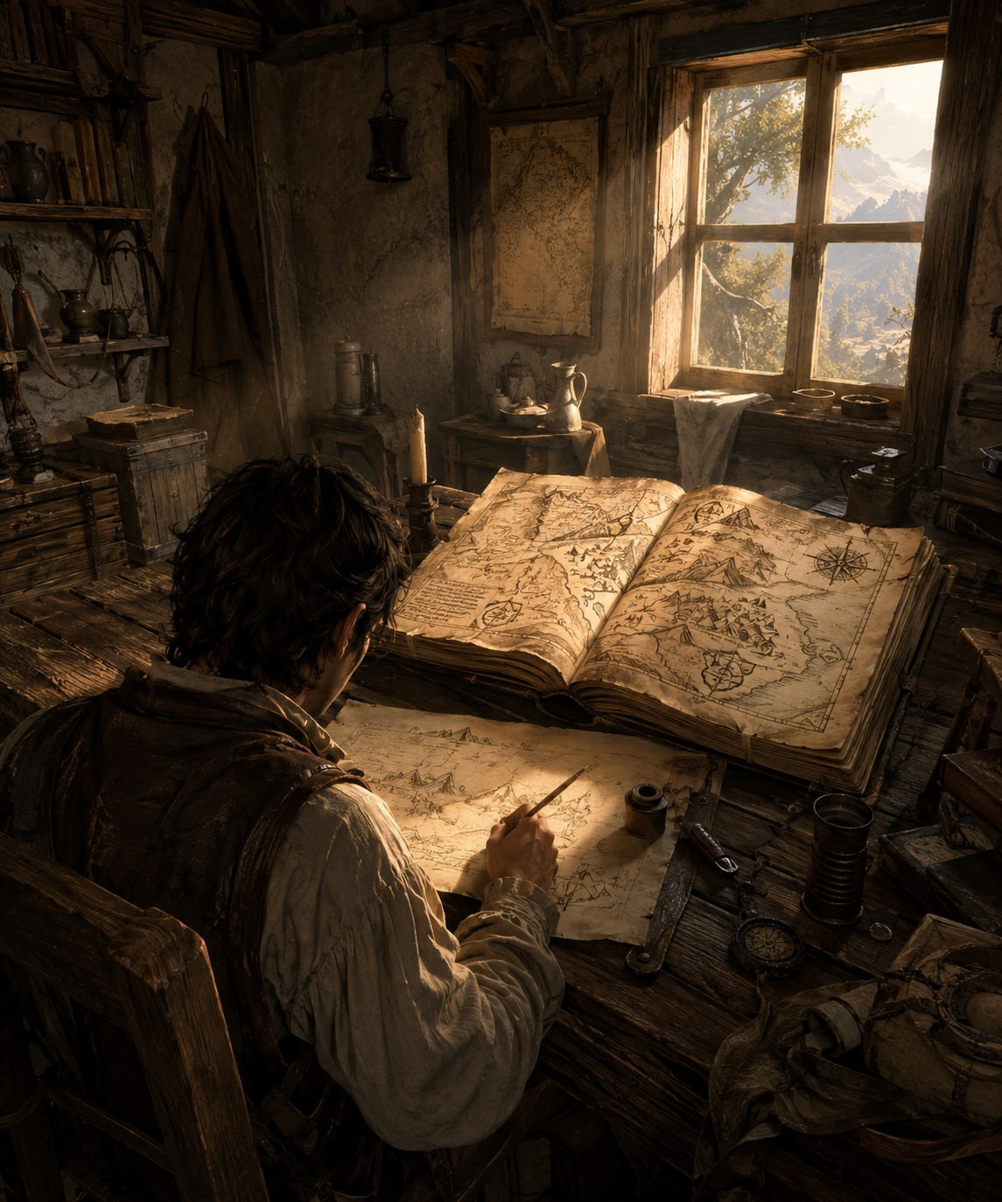
✧ Nohk and the map ✧

Chapter 2: The Reward Justifies the Risk
Part 1 – A New Route
By the time Nohk reached the inn, the discussion was already underway. The four men sat around a heavy wooden table. Their mugs were nearly full. No one seemed in the mood to drink.
They spoke of the expedition. The storm. The collapsed bridge. Ghim. The word ‘failure’ had begun to find its way into the conversation.
—Perhaps we should never have left Oldwood, —one of them said.
—Perhaps the vault does not exist.
Nohk remained by the doorway for a few moments, listening. While they argued about what had happened… he could think only about what might still happen. He walked to the table, set down the leather map case he had been carrying beneath his arm, and took a seat.
—I found another route.
The conversation stopped. Four pairs of eyes turned toward him. Calmly, he unrolled the new map across the table. It was no longer the simple drawing copied from Jorhm’s book. It was covered with notes, measurements, and lines added over the previous two days. Nohk placed one finger upon the valley of Oldwood. Then slowly traced a path westward.
—If we circle the mountain range through the Stone Desert, we can reach the highlands from the north. From there, we need only follow the ridge to the place marked on the map.
Kempht leaned over the table. He studied the route for a long moment. Then nodded slowly.
—It can be done.
Johf picked up the map. He examined it carefully, comparing the new markings with the route he still remembered. After a moment, he looked up.
—It is longer.
—Yes.
—And much more dangerous.
—Yes.
Nohk made no attempt to deny it.
—But it exists.
For a moment, no one spoke. Two days earlier, the expedition had ended at the edge of a cliff. Now, suddenly… there was a road once again.

And that alone was enough for failure to no longer seem final.

✦ ✦ ✦

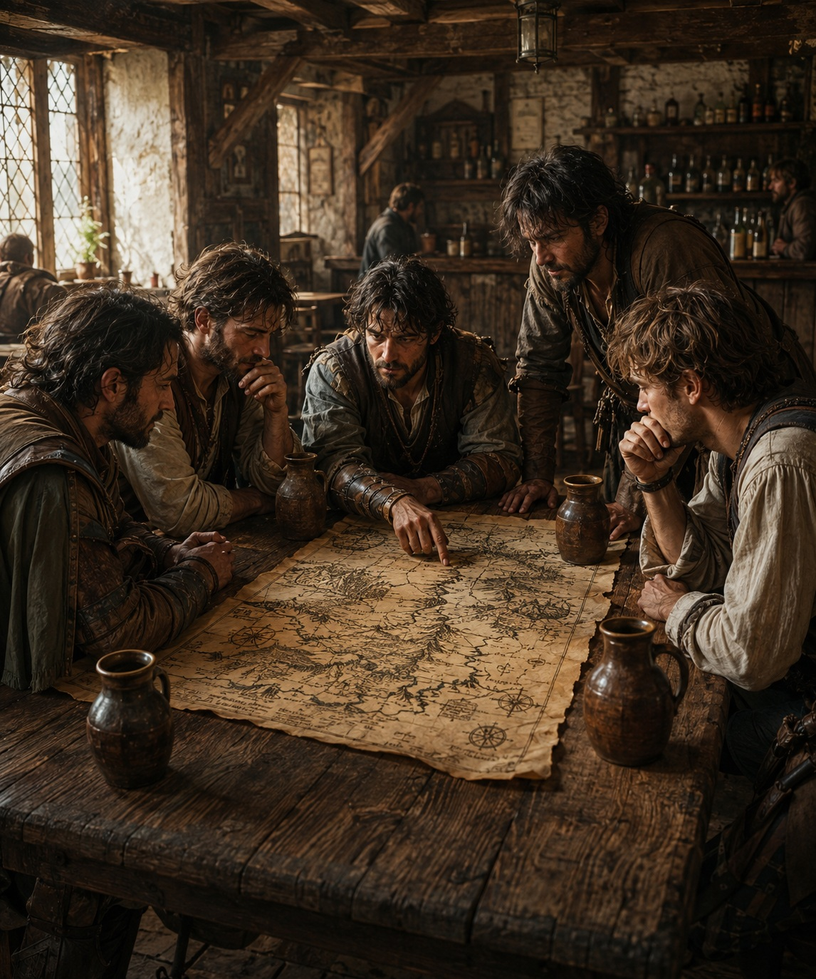
✧ The inn ✧

Part 2 – Does the Treasure Really Exist?
—There may be a way, —Tarhk said, without taking his eyes off the map—. But… does the treasure truly exist?
Silence settled over the table once more.
Nohk slowly untied the leather pouch from his belt and placed the key upon the table.
The iron had been blackened by centuries, yet the green stone still shone with remarkable brilliance.
—Look at it again, —he said.
No one answered.
—That stone alone is worth more money than any of us will earn in a lifetime. What kind of door requires a key like this?
Johf picked it up. He turned it slowly in his hands. He studied the royal crest engraved in the iron. The emerald. The craftsmanship. Then he looked up. Tarhk remained silent.
—We know the map exists.
—And the door must have existed as well.
—The key is here.
Johf gently laid it back upon the table.
—Three things are certain.
For a moment, no one spoke.
—Then the vault should exist as well.
The conclusion seemed perfectly reasonable. Then another followed.
—If someone went to the trouble of hiding something for three hundred years… it must have been something important.
—And if it was important… it must have been immensely valuable.
One idea led naturally to the next. Each argument made the previous one seem stronger. Each possibility became support for the next.
Little by little, they stopped asking what they actually knew.

Instead, they began asking which explanation made all the pieces fit together.

And none fit so neatly as the existence of the treasure.

Tarhk looked at each of his friends in turn.
—These are all assumptions.
No one answered.

Because assumptions were beginning to feel far more comfortable than doubt.

✦ ✦ ✦

Part 3 – The First to Leave
While some tried to prove that the treasure had to exist, Tarhk remained silent. He was not looking at the key. He was looking at his friends. He waited until they had finished speaking. Then he slowly pushed away the mug in front of him and said calmly:
—I will not go.
The conversations stopped. Kempht looked up in disbelief.
—What did you say?
—I will not continue the expedition.
The silence that followed was deeper than before. No one had expected that answer. They had discussed the new route. They had discussed the treasure. But no one had imagined that someone could walk away now. Precisely now. Tarhk slowly looked at each of his companions.
—Two weeks ago, none of us would have agreed to cross that marsh.
No one answered.
—A few days ago, none of us would have attempted to descend that cliff in order to climb the opposite wall.
Their eyes began to fall toward the table.
—And yet… we did.
He allowed several seconds to pass.
—Tell me something.
He looked at Nohk.
—Where is the limit?
No one answered. Because none of them knew.
Tarhk placed both hands upon the table. His voice remained calm.
—I do not know if the treasure exists.
He looked at the key. Then back at his friends.
—But I do know one thing.
He paused briefly.

—I have already lost enough.

✦ ✦ ✦

Part 4 – The Great Rationalization
For several moments, no one spoke. Tarhk’s question continued to echo in their minds.
Where was the limit?
It was Nohk who finally broke the silence.
—Let me ask you something else.
He looked at each of his companions in turn.

—What if we leave… and the treasure exists?

No one answered. It was not a new question. It had been present since the day they found the key. It was the possibility that turned every decision to quit into a risk.
Nohk continued.
—If we abandon the search now, we will never know.
He pointed toward the map.
—The treasure may be only a few days away. After everything we have done… are we really going to stop now?
Kempht slowly nodded. The idea carried a force that was difficult to resist. Then Nohk added:
—If we stop today, we will have lost everything we have invested.
Tarhk shook his head.
—No.
His answer came immediately.
—We have already lost it.
Silence returned to the table. Nohk held his gaze.
—Not yet.
—As long as there is still a chance of finding the vault, everything we have sacrificed can be recovered.
Tarhk remained still. Nohk continued speaking, his voice growing more certain with every word.
—Every undertaking faces difficulties. Unexpected expenses. Problems no one could have predicted. That does not mean the project has failed. It means we must finish what we started.
Johf began to nod. So did Kempht.
The idea was strangely comforting.

It transformed losses into an investment.
And uncertainty into a promise.

Tarhk watched them in silence. He understood then that they were no longer talking about the treasure.

They were searching for a reason that would make everything they had already sacrificed easier to bear.

✦ ✦ ✦

Part 5 – The Final Wager
For several moments, no one spoke again. The doubts had been expressed. The arguments had been made. There was nothing left to discuss. Only a decision remained. Nohk was the first to break the silence.
—I will continue.
He looked at each of his companions.
—Who will come with me?
Kempht answered without hesitation.
—I will.
Johf took only a few seconds longer.
—Count me in.
Then they all looked at Pohval. He remained silent. Finally, he slowly shook his head.
—No.
No one spoke. Pohval placed both hands upon the table.
—I have lost too much to keep gambling.
He looked at the key. Then at the map.
—If the treasure exists, I will never know what was inside that vault. But I still have my home. My land. And my life. I will not give those away as well.
Nohk did not answer. He did not try to persuade him. He knew that decision had already been made.
The expedition would continue. But with only three men.
One problem remained. Money. The first expedition had consumed nearly all of their resources. They needed another wagon. Animals. Tools. Provisions for several weeks. None of them had enough money to face the cost alone.
—I will sell the eastern field, —Nohk said.
He spoke with the same calmness he might have used when discussing a damaged roof. That land had belonged to his family for generations. It no longer seemed important.
Kempht looked up.
—I will sell my horses.
Johf remained silent for a moment.
—I will take a loan. I will repay it when we find the vault.
No one questioned those decisions. They accepted them with an ease that would have seemed impossible only a few weeks earlier.
The conversation continued deep into the night. Between calculations, distances, and supplies, the new expedition slowly took shape upon the inn’s table.
When they finally left the building, the plan was complete. They had not only decided to return to the mountains. They had decided to wager the rest of their lives on the belief that the treasure existed.

None of them felt that they were crossing a boundary.

And yet…
they had just left behind the last one that still connected them to the life they had known.

✦ ✦ ✦

Act IV – Erosion
“No man walks a long road
without leaving a part of himself upon it.

The greatest difficulty
is discovering, at the end of the journey,
what was truly left behind.”

—Fabhrius

Chapter 1 – Pursuit
Part 1 — The Eve
The days that followed were filled with activity. The new expedition slowly began to take shape. This time there would be no room for improvisation.
Every decision was carefully discussed. Every purchase answered a specific need. They had learned many things during their first attempt, and they would not repeat the same mistakes.
Nohk sold a small piece of land beside the river. Kempht acquired two strong horses. Johf obtained a loan by offering his house as collateral. Together, the three men gathered enough money to buy a new wagon, tools, ropes, tents, blankets, and provisions for several weeks. The new expedition was better than the first. And it was also far more expensive.
This time, none of them had any margin left for mistakes.
For several days they studied the map again and again. They corrected distances. Marked water sources. Calculated the time required to cross the Stone Desert during the night and avoid the heat of the day. They studied possible places to make camp and prepared reserves for any unexpected delay.
They no longer spoke like dreamers. They spoke like men convinced that success depended only on careful preparation. The mountain had defeated them once. It would not do so again.
The afternoon before their departure, they loaded the wagon. The tools were arranged with care. The ropes were coiled so they could be used at a moment’s notice. Each sack of food was counted twice. Each barrel of water was firmly secured to withstand the journey. When they finished, the wagon stood motionless before the stable, ready to leave at dawn.
The three men looked at it for a moment. That wagon was much more than wood, iron, and horses. It represented a second chance.
The conversation that night was different from those before. They no longer discussed whether the treasure existed. They spoke about how long it would take them to find it. They even began imagining what each of them would do with the king’s wealth. Buy land. Build a larger house. Hire workers. Live without ever worrying about money again. For a few hours, the expedition ceased to feel like a wager. It became, once again, a possible future.
They ate a generous meal at the inn. They spoke little about the journey. They laughed. When they parted, they agreed to meet before dawn.
Everything was ready. Only departure remained.
Nohk barely managed to sleep. He woke while the sky was still completely dark. The village rested in silence. The air was cold and damp. He dressed quietly and left the house, convinced he would be the first to arrive. Then he noticed something strange.
There was no sound of horses. He stopped. He looked toward the stable. The doors were open. For a moment he stood motionless, unable to understand. Then he began to run.
The stable was empty. The wagon was gone.
His heart began to race. He rushed back into the house.
The key was no longer where he had hidden it.
Neither was the map.
A thought crossed his mind before he even confirmed it.

He ran toward Johf’s house.
He struck the door.
No one answered.
He pushed it open with force.
The house was empty.
Then he understood the truth.

The second expedition had ended before it had even begun.

✦ ✦ ✦

Part 2 — A Necessary Decision
A few minutes later, Nohk and Kempht were examining the stable, searching for clues. They needed to understand what had truly happened.
Nohk studied for a moment the deep tracks the wagon wheels had left in the mud. Beside him, Kempht stared at the road with the same expression of disbelief.
Johf had simply waited until everyone was asleep. He had loaded the wagon. Harnessed the horses. Taken the key, the map, the provisions, and the tools. Then he had left before dawn. None of it had been an impulse. It had been a plan.
—He was already ahead of us before we even went to sleep, —Kempht murmured.
Nohk did not answer. His eyes remained fixed on the wagon tracks. Those marks seemed to disappear into the distance carrying far more than a wagon. They had not lost a few possessions. They had lost the expedition. They had lost the possibility of recovering everything they had sacrificed during the first attempt. The land he had sold. The horses. The wagon. The money. The weeks of work.
Everything now depended on a single man who was heading toward the mountains with several hours’ advantage. Nohk closed his eyes for a moment. He understood then that the treasure was no longer merely a promise of wealth. It had become the only way to give meaning to everything they had sacrificed.
If Johf found the vault before they did… Everything would be over. Everything would have been for nothing.
—We have to catch him, —he finally said.
Kempht looked up.
—How?
They had no horses. No money. No time. And every minute they remained there increased the distance between them and Johf.
Then Nohk looked toward the other side of the village. There, beside a wooden fence, two horses stood tied in front of a small farm’s barn. He watched them silently. Then he looked back at the wagon tracks. And once again toward the horses. It was not a difficult decision. It was simply a decision that, only a few weeks earlier, he would never have considered.
—We will return them when this is over, —he said calmly.
Kempht immediately understood what he was suggesting. He did not try to convince him otherwise. They had crossed too many boundaries to stop now.
The wind moved across the rooftops of Oldwood. They walked silently through the shadows. Nohk slowly opened the fence. The horses raised their heads as they sensed their presence. One of them gave a quiet whinny. The two men remained completely still. Waiting.
Then they untied the reins. They led the animals quietly to the road. They mounted. And they left the village before dawn.
Behind them remained the houses, the lands they had cultivated since childhood, and the peaceful life they had once known.
They were searching for a thief.

Without realizing it…
they had just become two more.

✦ ✦ ✦

Part 3 — The Desert
For two days they followed the wagon tracks. The trail was easy to find.
Johf was carrying too much weight and moving slowly through the Stone Desert. The wheels had left deep marks between the rocks, and from time to time they found signs of his passage: The remains of a campfire. Broken branches. The tracks of the horses.
Every hour that passed brought them closer. But it also carried them farther away from what they had once been. They were no longer traveling as companions searching for a fortune. They did not share plans. They did not speak about the future. Now they were hunting a man.
On the third day, as the sun began to descend, they saw a thin column of smoke rising among the stone formations. The wagon was there. Johf had made camp beside a group of rocks, searching for some shade. The horses were resting. The map and the key were still with him. For several minutes they watched from a distance. Everything they had lost was there before them.
Kempht looked at Nohk.
—We can take it now.
Nohk watched the camp in silence. He did not answer. They would wait.
Night slowly descended over the desert. Johf’s fire weakened until it became nothing more than a few glowing embers. The wind began to move through the stones. Exhaustion finally overcame the man sleeping beside the wagon. Then they moved. Without words. Without sound.
They approached slowly. They untied the horses. Removed the equipment. Loaded the wagon. For several minutes, everything remained silent.
When they were about to leave, Johf opened his eyes. At first, he did not understand what he was seeing. Then he rose suddenly.
—Nohk?
No one answered. He ran out of the camp. The wagon was already beginning to disappear into the darkness.
—Wait!
The horses continued forward.
—Don’t leave me here!

Slowly, the distance grew.
Johf could no longer follow.
And he watched as the wagon moved away, leaving him at the mercy of the desert.

Without a struggle.
Without an argument.

Without mercy.

✦ ✦ ✦

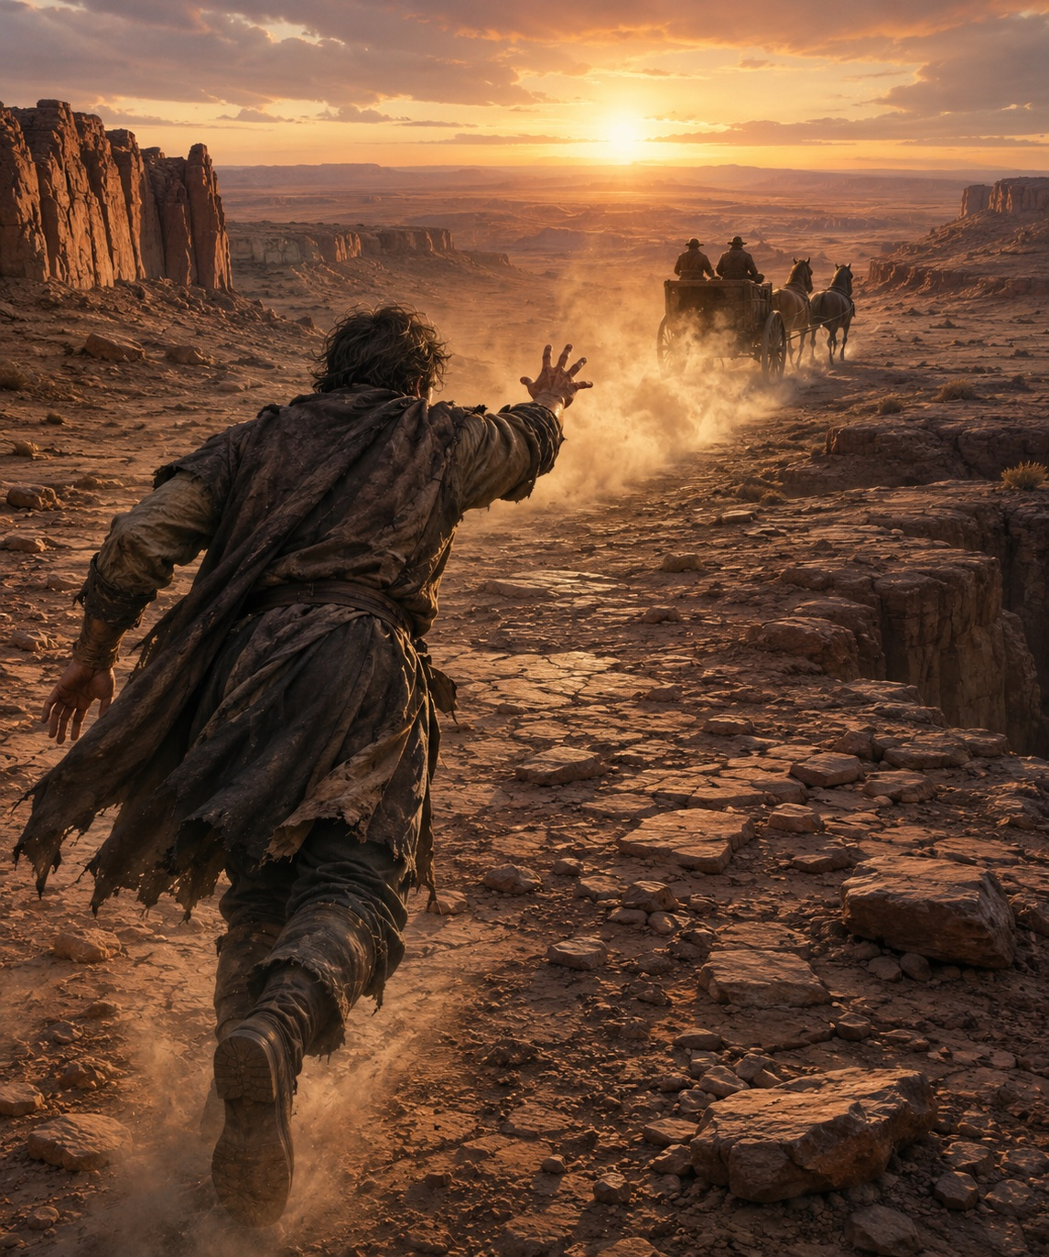
✧ Abandoned in the Desert ✧

Chapter 2 – The End of the World
Part 1 — The Cliff
After several days of travel, they finally reached the place marked on the map. The land rose gently toward a vast plain covered in grass.
The landscape was strange. Too open. There were no trees. No ruins. No mountains. Only the wind moving across the endless expanse.
They walked for a long time without finding anything.
Then the land ended. The ground suddenly disappeared beneath their feet, replaced by an immense cliff descending hundreds of meters toward the sea. Beyond it, there was no other land. Only water stretching all the way to the horizon.
It was the end of the continent. The very edge of the world.
The map had led them there. And there was nothing.
They remained motionless, staring at the landscape. Behind them, the plain stretched as far as the eye could see. Before them, there was only the sea, the wind, and the emptiness. There was nowhere else to search.
They had crossed marshes. Traversed deserts. Climbed mountains. Only to reach that place. They had never imagined that it could be empty. Reality had finally caught up with them.
Kempht dropped his pack onto the grass. Nohk did the same. Neither felt the need to speak. They remained there for a long time, listening to the sound of waves crashing against the rocks far below.
Old Jorhm had tried to warn them. It was only a legend. They had chosen to believe something else. They had mistaken a desire for a promise. And now the world offered them an answer that was unbearably simple. There was no treasure. Only the sea.
Nohk lay down on the grass. The urgency that had ruled his life for weeks seemed to disappear. He looked at the sky. He watched the clouds drift slowly above him. The sea breeze carried the scent of grass and salt. Fresh. Gentle. He closed his eyes for a moment and listened. The sound of the wind. The distant cries of seabirds. He saw them flying. Free.
A gull crossed the sky above them. It glided for a few moments, carried by the wind, and disappeared beyond the edge of the cliff.
Kempht followed its flight with his eyes. Slowly, he stood and walked toward the edge.
He leaned carefully over the void. The drop was dizzying. Far below, the sea struck the rocks with tremendous force, sending columns of white foam into the air. Then he saw it.
About fifty meters away, attached to the cliff face, a narrow ledge descended diagonally until it disappeared beneath a rocky overhang.
He stared at it for several seconds, unable to look away. Then he turned his head.

—Hey, Nohk… is that a path?

✦ ✦ ✦

Part 2 — The Path
It was impossible to know whether the narrow ledge actually led anywhere. It could end a few meters ahead. It could collapse. It could be nothing more than an irregularity in the rock, lost among hundreds of similar cracks. But after everything they had endured, every possibility was worth exploring.
—We have to find out where it leads, —Nohk said.
Kempht did not hesitate.
—I will go.
He approached the edge of the cliff and carefully began to descend until he reached the ledge. He placed both feet on the narrow strip of stone and remained still for a moment, allowing himself to adjust to the height. The wind struck the cliff face with force. Far below, the sea crashed against the rocks with a constant roar. The ledge descended gently along the mountain until it disappeared behind a rocky outcrop.
—It might be the way, —he shouted.
Nohk remained above. He did not descend. He did not offer a rope. He did not search for another route. From there, he could see everything. If the ledge collapsed, he would know. If it led somewhere, he would know that as well.
Kempht began to walk. One step. Then another. He moved slowly, placing one hand first, then one foot, testing each section of rock before putting his full weight upon it. He did not seem afraid. On the contrary. Each meter he crossed reminded him of the same thought that had brought him there. The treasure was close.
Nohk watched him in silence. Long ago, he would have descended with him. He would have shared the risk. He would have protected his friend. But that man had disappeared long before they reached the cliff. The storm. The mountain. The betrayal. The death. Each loss had erased something from him. Now only the objective remained.
Kempht took another step. And another. He slowly raised his left foot, searching for a new place to rest it. The stone cracked. For an instant, everything seemed to stop. As if the mountain itself were deciding.
Then the rock gave way.
His body lost its balance.

And he fell.

Nohk waited.
He remained still for several seconds. Then he slowly walked to the edge.
He looked down.
He could not see the body. Only the sea striking the rocks again and again. He waited a moment longer.
Then he stepped away from the cliff and lowered himself onto the grass.
He rested his back against the ground.
The world continued exactly as before. He remained there for hours. He was no longer in a hurry.
When the sun began to disappear, he lit a small fire. The flames illuminated his face as darkness covered the coast.
One thought returned again and again. Kempht had been completely certain. He had descended without hesitation.
What if he had died only a few steps before reaching the end?
Nohk continued watching the fire for a long time. Finally, he stood. He lit the oil lamp. Walked toward the edge of the cliff. And began to descend.
Night had transformed the mountain into an immense black mass. The wind was colder. The sea seemed even farther below. He placed both feet on the ledge. Took a deep breath. And began to move. Step by step. Without looking down.
The rock slowly curved around the outcrop. The ledge ended. Before him appeared a dark opening. The entrance to a cave. A tunnel leading deep into the heart of the mountain.
Nohk remained still.
Listening.
No sound came from within. He raised the lamp. The light moved across the stone walls.
He walked several steps into the cave.
And then the flame revealed something impossible, only a few steps ahead.

An iron door, embedded in the wall of rock.

✦ ✦ ✦

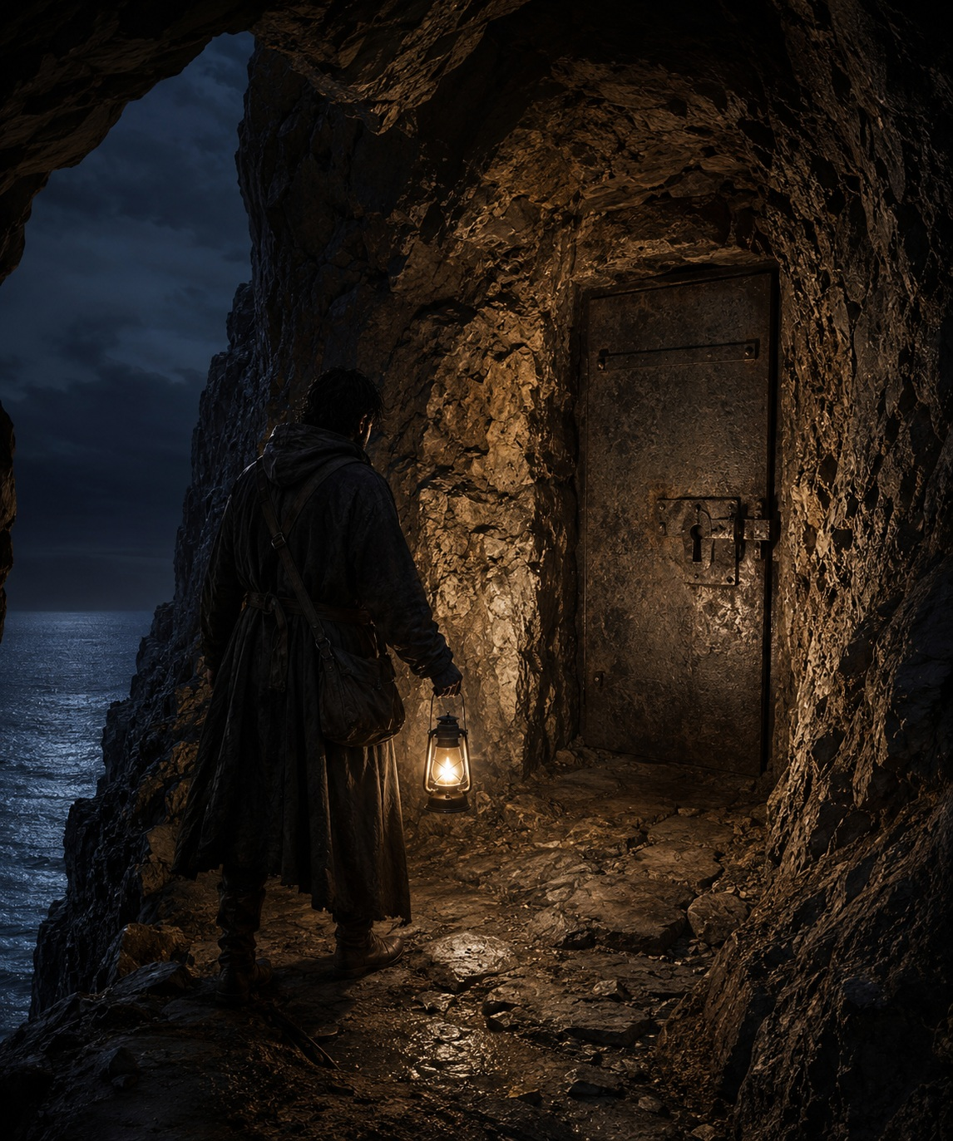
✧ The door ✧

Act V - Destiny
“No choice
reveals its true nature
at the moment it is born.

Only what it leaves behind
bears witness to what it truly was.”

—Fabhrius

Chapter 1 — The Truth
Part 1 — The Vault
Nohk hurried toward the door. There was no longer any doubt. The vault was real. They had all been wrong. The iron door was covered in rust and scarred by the passage of time.
There were no royal emblems. No ancient inscriptions.
Only the door.
And a lock.

He slid the key into it.
It fit perfectly.

He turned it with all his strength. A sharp metallic crack echoed through the cave, like the awakening of an ancient mechanism after centuries of silence. The lock yielded.
He braced himself against the heavy iron door and pushed. Slowly, it began to open.
A current of cold air drifted out from the darkness beyond. Still air. Ancient air. Air that had remained trapped there for centuries. He raised the lantern, trying to pierce the darkness.
He hesitated.
Only a few steps now separated him from the end of his search.
A moment later, he stepped inside. The lantern’s light crept slowly across the chamber.
Bare rock. Naked walls. Something pale lay on the floor.
He moved closer. Bones. A skull. He swept the lantern farther. Another. And another. The remains of several men lay scattered near the entrance, wrapped in the rotting remnants of clothing that had almost completely vanished with time. Only their bones remained. The sight unsettled him. He stared at them for several long seconds. Then he walked on.
A few steps later, the lantern illuminated the far wall. It was the end of the chamber. He crossed the room and laid a hand against the stone. Solid. Cold. Slowly, he turned around.
From there he could see the entire vault.
It was a circular chamber carved into the rock. No windows. No other doors. No hidden passages. No inscriptions. No symbols. Only the skeletons of those men. Nothing else.

It was empty.

A metallic sound shattered the silence.
The door was moving.
For a single second, he watched as it slowly began to close.
Before he could react, the massive slab of iron slammed into the frame with a deafening crash.
The entire mountain seemed to tremble.
The key was thrown from the lock. It struck the stone floor once… Then disappeared beneath the door.
His mind refused to accept what he was seeing. It couldn’t be happening.
—No!

He lunged toward the entrance.
He shoved against the iron with all his strength.
He pounded it with his fists.
Once.
Then again.
He tried to force it open.
But the door did not move.
It was sealed.

And it could no longer be opened from the inside.

✦ ✦ ✦

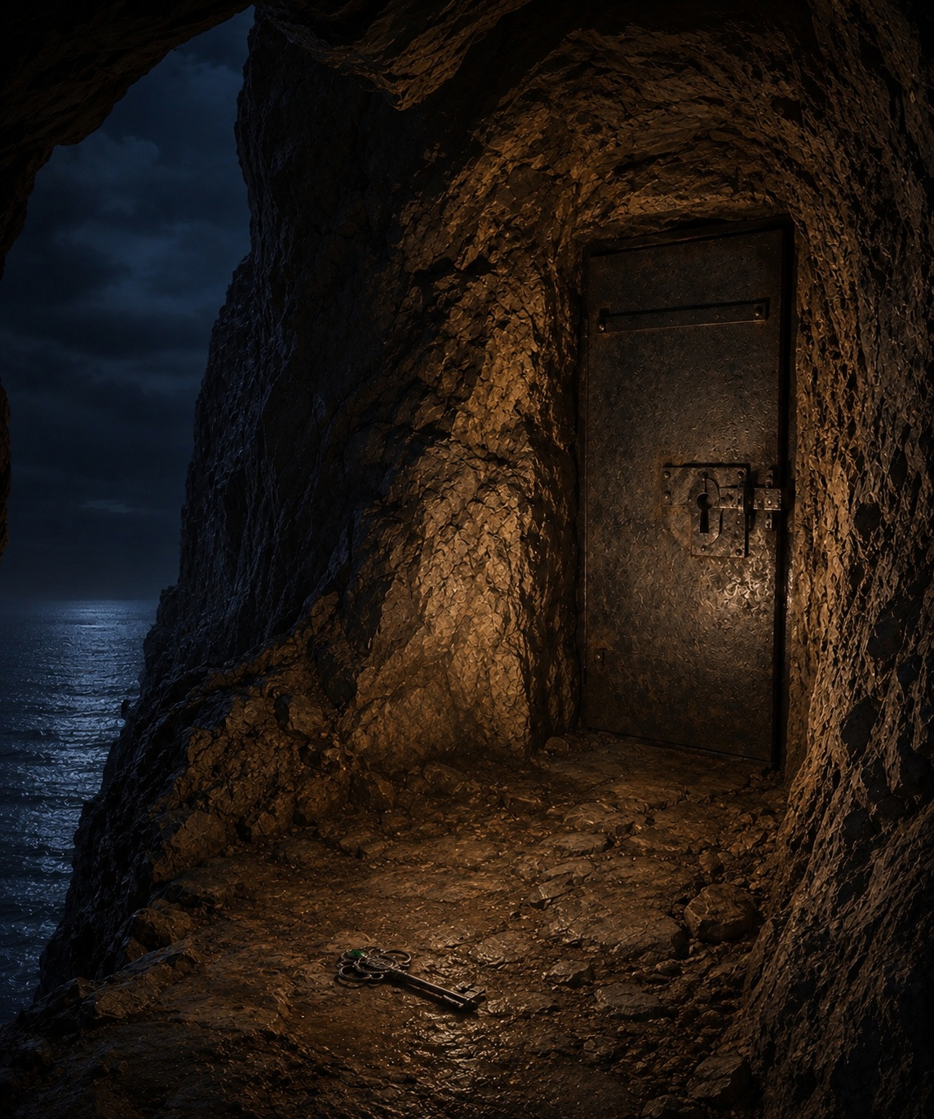
✧ No way out ✧

Part 2 — A New Day
After the night came a new day.
The sun shone over the sea as a raven flew into the cave.
Morning light streamed through the entrance, illuminating the iron door. And there, upon the stone floor, a flash of green caught the bird’s attention.
The raven hopped closer and studied the object for a few moments.
Then it seized the key in its talons and took flight. Within moments, it had left the cave behind. The spring sky seemed made for nothing but its wings.
It soared above the cliffs, gliding among the clouds before climbing higher and higher into the open sky. It crossed mountains. Forests. Rivers. For a long time it drifted upon the rising currents that climbed from the valleys below.
Until, somewhere far away, it released the key.
The iron object spun through the air, struck the ground, bounced once… and disappeared into the grass.

There it remained. For a time.

Until one quiet morning,
near the village of Wetwood, a farmer named Jahnk was walking along a dirt road on his way to the market.
It was a pleasant day. The sky was clear.
His thoughts were occupied with simple things.
The harvest. The livestock. The price of wheat.
Then he noticed something glinting among the grass.
He knelt down. Brushed aside a few branches. And picked it up.

It was an old iron key.
Heavy. Strangely beautiful.
A green stone gleamed in its handle.

Jahnk turned it over in his hands with quiet curiosity.

A coat of arms was engraved in the iron.
A symbol he did not recognize.
He smiled.
—Today is my lucky day.

He slipped the key into his bag… and continued on his way.

✦ ✦ ✦

End of the Tale
✦
Omniscientis

From the Infinite Library
Catalogued Volumes
◆ The Key
◆ The Crystal Ball
Records Awaiting Cataloguing
◇ The Lamp
◇ The Seed

